

**Company Overview**:

Uber is a multinational ride-sharing and transportation company founded in 2009. It provides a platform that connects riders with drivers, offering a convenient and flexible mode of transportation in various cities worldwide. Uber's services include ride-sharing, food delivery (Uber Eats), and more.

**Product Dissection and Real-World Problems Solved by Uber:**

Uber has effectively addressed several real-world challenges through its innovative product offerings:

**Problem 1: Access to Convenient Transportation**

* **Real-World Challenge:** In many cities, access to reliable and convenient transportation can be challenging, especially during peak hours or in areas with limited public transportation options.
* **Uber's Solution:** Uber provides an easy-to-use app that allows users to request rides with just a few taps on their smartphones. It solves the problem of accessing transportation quickly and conveniently, bridging the gap between supply (drivers) and demand (riders).

**Problem 2: Safety and Accountability**

* **Real-World Challenge:** Safety concerns often arise when using traditional taxi services, as riders may have limited information about the driver and the vehicle.
* **Uber's Solution:** Uber addresses safety concerns by providing riders with information about their driver, including their name, photo, and vehicle details. Riders can also share their trip details with trusted contacts, enhancing accountability and safety.

**Problem 3: Payment Convenience**

* **Real-World Challenge:** Traditional taxi services may require riders to pay with cash or go through a complex payment process.
* **Uber's Solution:** Uber offers a seamless cashless payment system. Riders can link their credit cards or digital payment methods to their Uber account, making payments easy and convenient.

**Problem 4: Efficient Driver Routing**

* **Real-World Challenge:** Taxi drivers often face challenges in finding passengers efficiently, leading to wasted time and fuel.
* **Uber's Solution:** Uber's app uses GPS technology to match drivers with riders and provide optimized routing. This solution improves driver efficiency and reduces wait times for riders.

**Problem 5: Price Transparency**

* **Real-World Challenge:** Riders may encounter unexpected pricing with traditional taxis, especially during peak demand.
* **Uber's Solution:** Uber introduced upfront pricing, which allows riders to see the estimated cost of a trip before confirming the booking. This transparency helps riders make informed decisions about their transportation.

**Case Study: Real-World Problems and Uber's Innovative Solutions**

Let's dive deeper into one of the problems Uber solves and how it provides an innovative solution:

**Problem: Access to Convenient Transportation**

**Real-World Challenge:** In many cities, especially during rush hours or in areas with limited public transportation, getting a taxi quickly can be a daunting task. Traditional taxi services may not be readily available or may have long waiting times.

**Uber's Solution:**

Uber addresses this challenge by offering a user-friendly mobile app that allows riders to request rides on-demand. Here's how Uber's features solve this problem:

* **App-Based Booking:** With the Uber app, riders can request a ride with just a few taps on their smartphones. They don't need to call a taxi dispatcher or hail a cab on the street.
* **Driver Availability:** Uber's platform connects riders with available drivers in their vicinity, reducing wait times significantly.
* **Real-Time Tracking:** Riders can track the driver's location and estimated time of arrival in real-time through the app, eliminating uncertainty.
* **Ride Options:** Uber offers various ride options, such as UberX, Uber Black, and Uber Pool, giving riders flexibility and choices to suit their needs.
* **Cashless Payments:** Payments are handled seamlessly through the app, eliminating the need for cash and providing convenience.

Uber's innovative solution to the problem of access to transportation has transformed the way people move around cities, making it more convenient and efficient.

**Schema Design Based on Top Features:**

Now, let's proceed to design a schema that reflects the data structure of Uber's core features. We will focus on the key entities, attributes, and relationships involved in Uber's operations.

**Entities:**

1. User Entity:
   * + - UserID (Primary Key)
       - Username
       - Email
       - Phone Number
       - Payment Information
2. Driver Entity:

* DriverID (Primary Key)
* Driver Name
* Vehicle Information
* Driver Ratings

1. Ride Entity:

* RideID (Primary Key)
* Rider UserID (Foreign Key referencing User Entity)
* DriverID (Foreign Key referencing Driver Entity)
* Pickup Location
* Drop-off Location
* Ride Status (e.g., requested, in progress, completed)
* Fare

1. Payment Entity:

* PaymentID (Primary Key)
* Rider UserID (Foreign Key referencing User Entity)
* DriverID (Foreign Key referencing Driver Entity)
* RideID (Foreign Key referencing Ride Entity)
* Payment Amount
* Payment Date

**Relationships:**

* **Users request Rides:** Each user can request multiple rides.
* **Drivers provide Rides:** Each driver can complete multiple rides.
* **Users make Payments:** Each user can make payments for multiple rides.
* **Drivers receive Payments:** Each driver can receive payments for multiple rides.

**ER Diagram:**

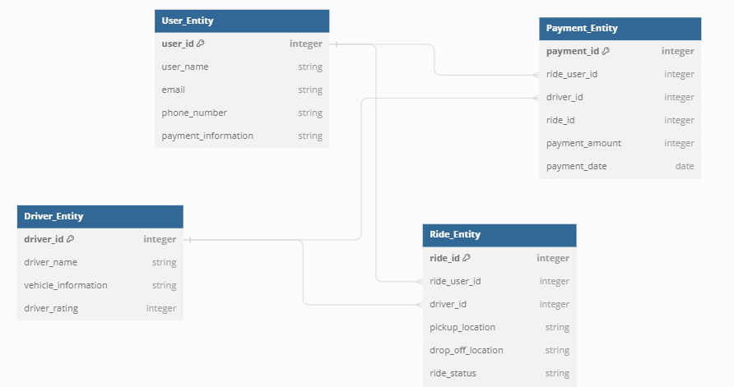

Link for Er diagram for more understanding:

https://dbdiagram.io/d/6505ba7802bd1c4a5eb1bd91

**Conclusion:** In this case study, we explored Uber's product, identified real-world problems it solves, and designed a schema for its core features. Uber has successfully addressed challenges related to transportation convenience, safety, payment, efficiency, and price transparency. Its data architecture, represented by the schema, plays a crucial role in enabling the seamless operation of its platform, connecting riders and drivers efficiently.